**Subset Sum Problem and the NP Algorithms**

Based on this paper, the main content will basically explore on subset sum problem as well as the NP-complete problem (NP algorithms mixed with the heuristic algorithm). In this case, the document will illustrate its effect in different scenarios, competence or efficiency, the complexity of storing as well as time and finally the solutions offered in hand along with what is supposed to be performed in order to solve it. In computer science, there is actually a complexity problems class which is well recognized as (NPC) NP-complete, only because they have complete data or information about each problem within NP complexity class. However, the method of providing evidence about a problem is NPC is mainly to generate a polynomial (quick) transformation from a recognized NPC problem into problem considered as well as reflecting that the alteration yields similar solutions both challenges. The technique employed for resolving NPC optimization challenges is by making heuristic algorithms which provide or suboptimal resolutions to deem challenge or problem.

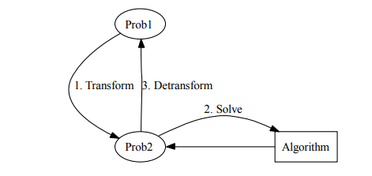

Conversely, the heuristic algorithms can also employ the transformations in order to provide approximate resolutions to optimization problems of NPC as illustrated in the above figure (Traversa, Ramella, Bonani, & Di Ventra, 2015).

The subset sum problem is mainly an NP-complete class member of computational problems, without recognized polynomial time algorithm. In the theory of computational complexity, the problems in NP-complete class do not have recognized algorithms which run within polynomial time. NP-completeness study is basically crucial, as computer science issues or challenges lurk a lot of guises athwart various disciplines, from chemical data or information to networking (König, Lohrey, & Zetzsche, 2016).

Base on this case, the efficiency of subset sum problem as well as NP algorithms, KNAPSACK is basically a well-recognized and was reflected as NP-complete in the year 1972. However, KNAPSACK usually remains NP-complete even though the size of all objects is equivalent to its value; this specific case is recognized as a subset-sum problem. The most competent or efficient fully polynomial-time rough calculation scheme recognized for a subset–sum problem is when you are offered a number set (S) as well as target number (t), with an aim of getting a subset (S’) of S such the components in it amount to (t). Although the challenge or problem, in this case, looks deceptively easy, resolving it is actually exceeding hard in the case where we are not provided with extra information or date. Thus in, later on, this will reflect that it is actually an NP-complete problem and probably an efficient algorithm.

A somewhat more efficient usually checks out each and every potential 2n subsets. One of the typical ways of doing this is by expressing all values from zero (0) to 2n -1 through binary note and structure a subset of components whose indexes as basically similar to bit positions which keep up a correspondence to 1. Subset sum is actually interesting in the logic that its decimal or binary is more likely to be proved since NP-complete though its unary editions appear to facilitate a polynomial actually looking dynamic programming resolution (Song, Song, & Pan, 2017).

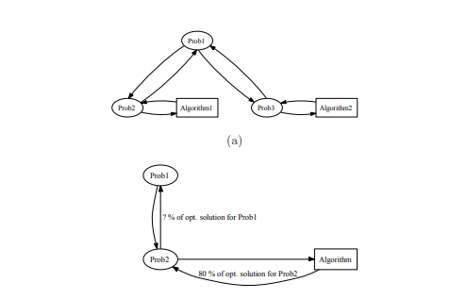

Based on the case of the subset-sum problem along with NP-algorithms, there are various effects that occur or arises based on its application. However, the effect on most of the time differs based on the scenario used. For example, in this case, I will consider the effect of different scenarios, for instance, in converting SPP to SP. Take an example where we have a 50 ai subset-sum problem and all in between 1 & 2020, having T < 50(220) < 2 26. Resolving this case of SSP can be crudely broken. The effect, in this case, is that the Ai concludes the Bi, which in return concludes C2j through C50j consecutively. Another scenario in the non-asymptotic case, based on this case weights are consistently distributed from 71-80, hence its accomplishment probability is basically near to case where each and every weight contains a bit length of 74 along with dhm ≈80/74, as compared to case all weights contain a bit length of 80 and dhm ≈80/80 resulting to 1.

However, while using heuristic algorithms design, an individual can decide to basically return solution which would operate fine, though it may actually be a good idea to keep or store the resolution in the given problem instance. Therefore, by so doing, it would actually make it essential to keep or store a resolution for all algorithms, which would need a large amount of memory than the problem input. Identifying an issue just like NP-complete will actually conserve both effort and time for the central processing unit scientist. To be familiar with special NPC problem case, that is more likely to be resolved optimally within polynomial running time or utilize an algorithm with typical polynomial running time that finds a close optional solution. The broad-spectrum aim in computer science is actually to look the best potential solution to each and every problem as quick as possible, which mostly means within polynomial time (Wan, et al., 2015).

**REFERENCE**

König, D., Lohrey, M., & Zetzsche, G. (2016). Knapsack and subset sum problems in nilpotent, polycyclic, and co-context-free groups. *Algebra and Computer Science*, *677*, 138-153.

Song, B., Song, T., & Pan, L. (2017). A time-free uniform solution to subset sum problem by tissue P systems with cell division. *Mathematical Structures in Computer Science*, *27*(1), 17-32.

Song, T., Luo, L., He, J., Chen, Z., & Zhang, K. (2014). Solving subset sum problems by time-free spiking neural P systems. *Applied Mathematics & Information Sciences*, *8*(1), 327.

Traversa, F. L., Ramella, C., Bonani, F., & Di Ventra, M. (2015). Memcomputing NP-complete problems in polynomial time using polynomial resources and collective states. *Science advances*, *1*(6), e1500031.

Wan, L., Li, K., Liu, J., & Li, K. (2015). GPU implementation of a parallel two‐list algorithm for the subset‐sum problem. *Concurrency and Computation: Practice and Experience*, *27*(1), 119-145.